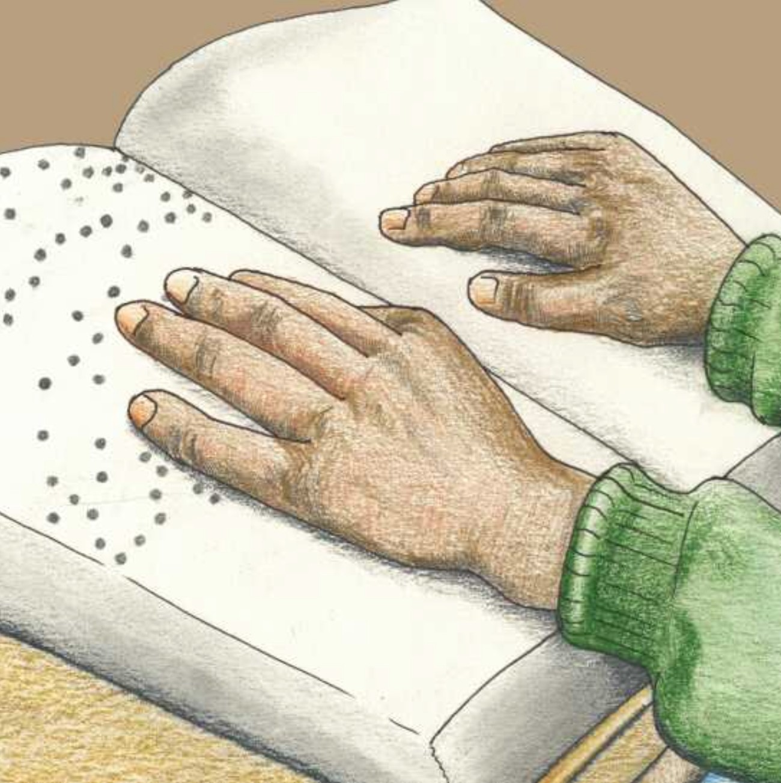Thk whistling Man

Magda Swartz Petrus Amuthenu

Learn Sight Words

The Whilstling Man

Written by: Magda Swartz Illustrated by: Petrus Amuthenu

Language: English Level: Level 4

Source: The whistling man from African Storybook Creative Commons License

This work is licensed under a Creative Commons Attribution-NonCommercial- ShareAlike 4.0 International License. <https://creativecommons.org/licenses/by-nc-sa/4.0/>

More books like this one are available at <https://storybooksnamibia.net/>

This edition adapted and published by: [http://www.freekidsbooks.org](http://www.freekidsbooks.org/)

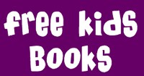

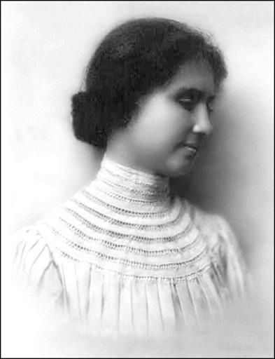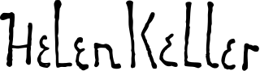

“Optimism is the faith that leads to achievement. Nothing can be done without

hope and confidence.”

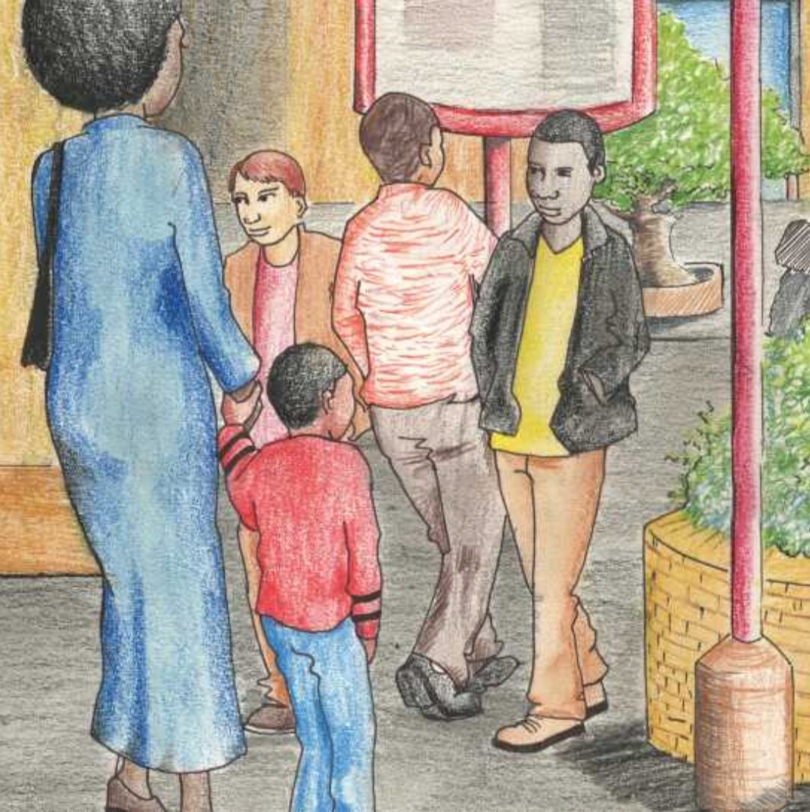

It’s Saturday and Rico is going to town with his mother. He likes going to town.

Town is exciting! There are lots of things to see.

5

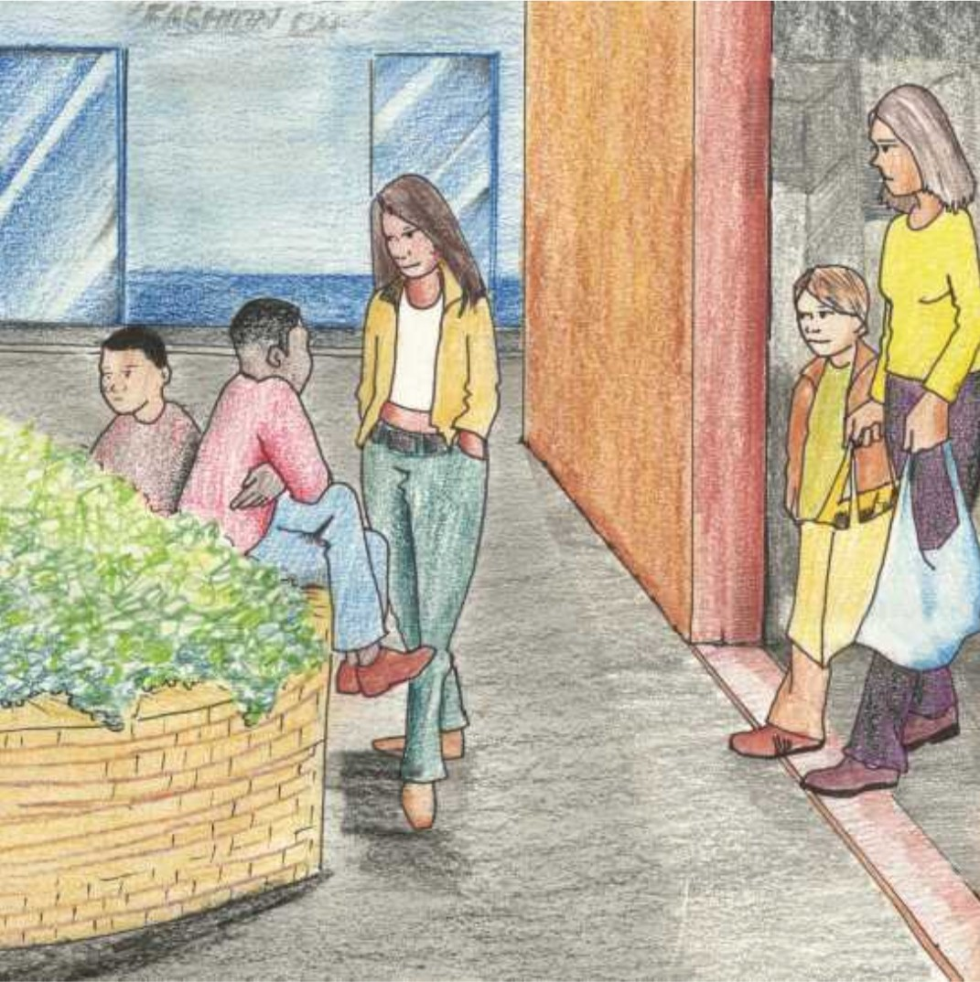

Rico holds his mother’s hand very tightly. Streams of people are passing by.

7

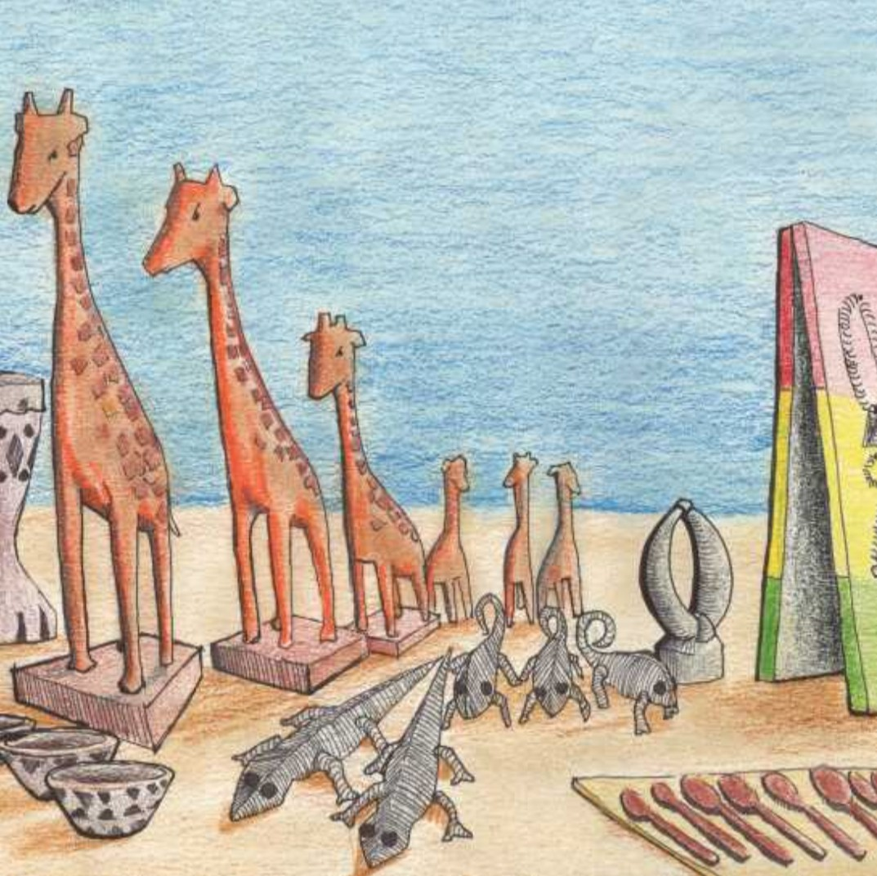

There are stalls selling beautiful handmade crafts.

9

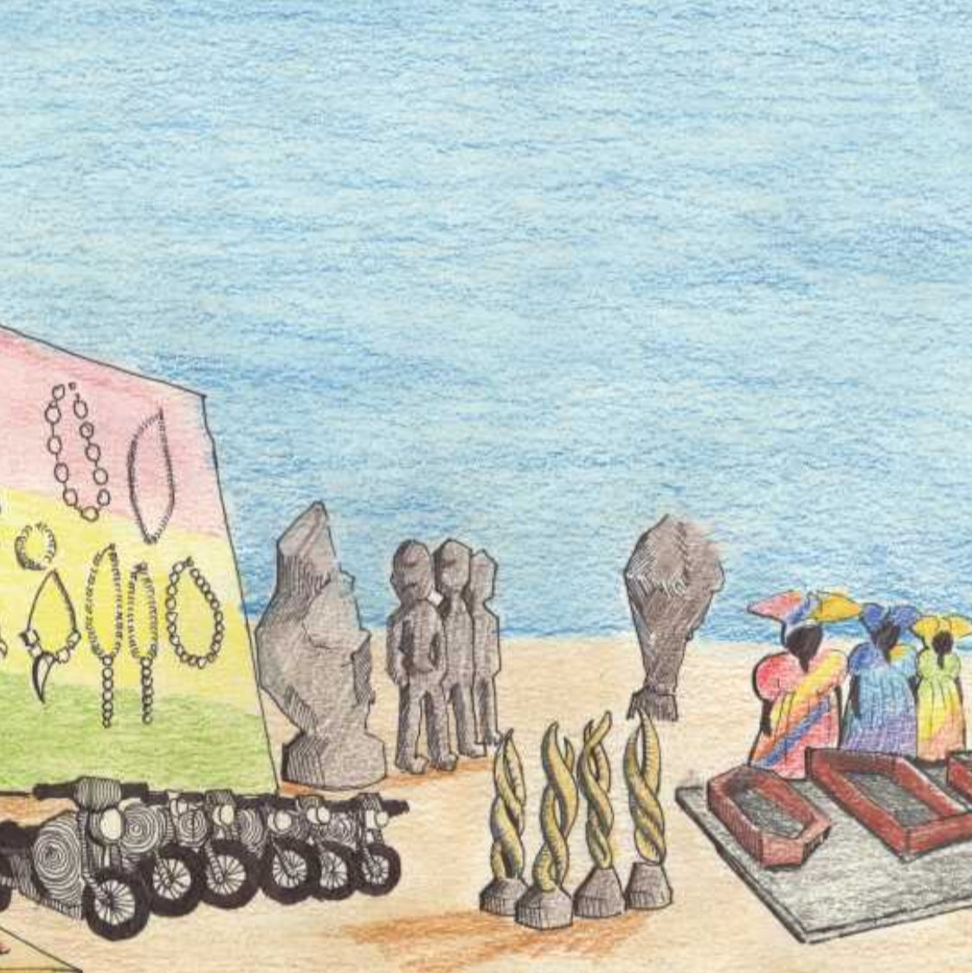

There are small giraffes carved out of wood, chameleons and lizards made out of wire and coloured beads, and jewellery made from ostrich egg shell.

11

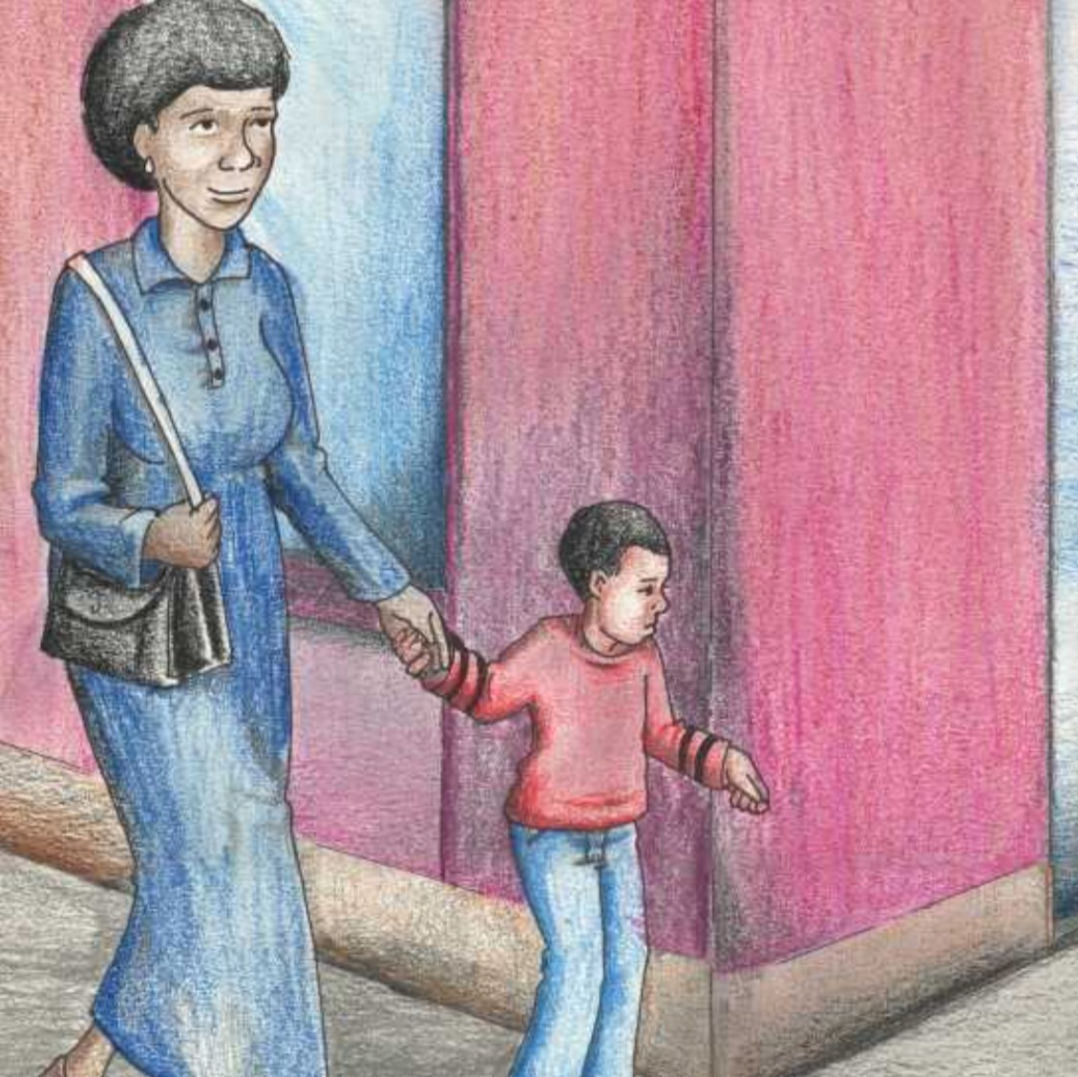

Then he hears it! Someone is whistling the sweet melody of ‘Amazing Grace.’ He stops to listen. Where is it coming from?

13

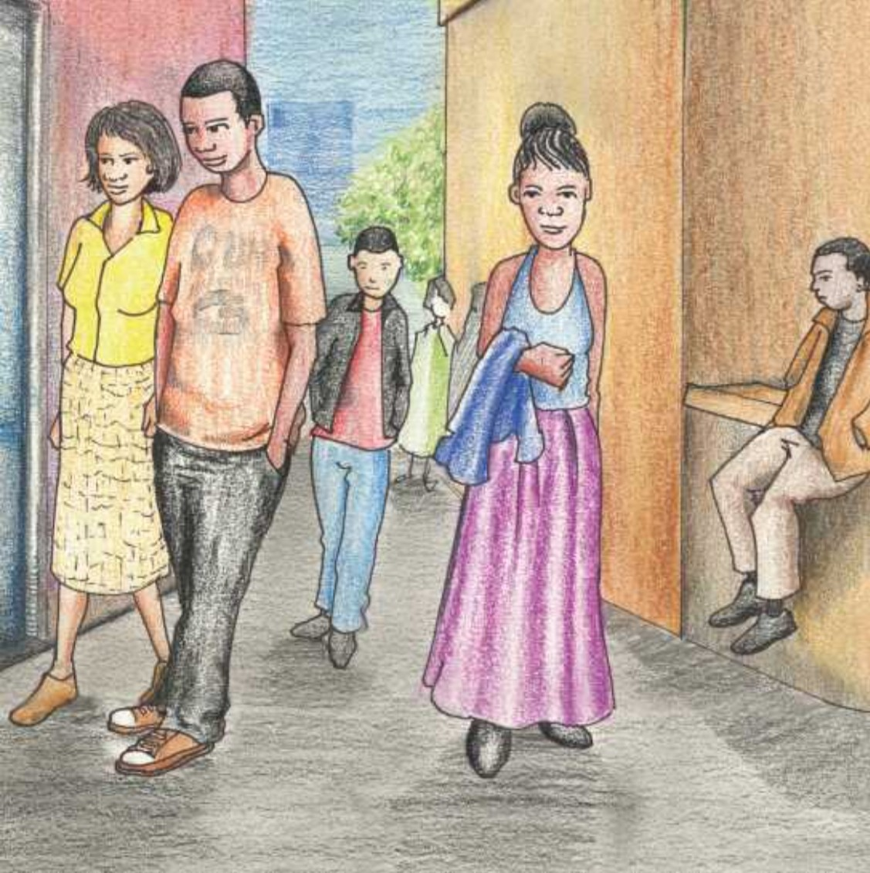

“I’ve never heard anyone whistle so beautifully before,” he thinks to himself.

15

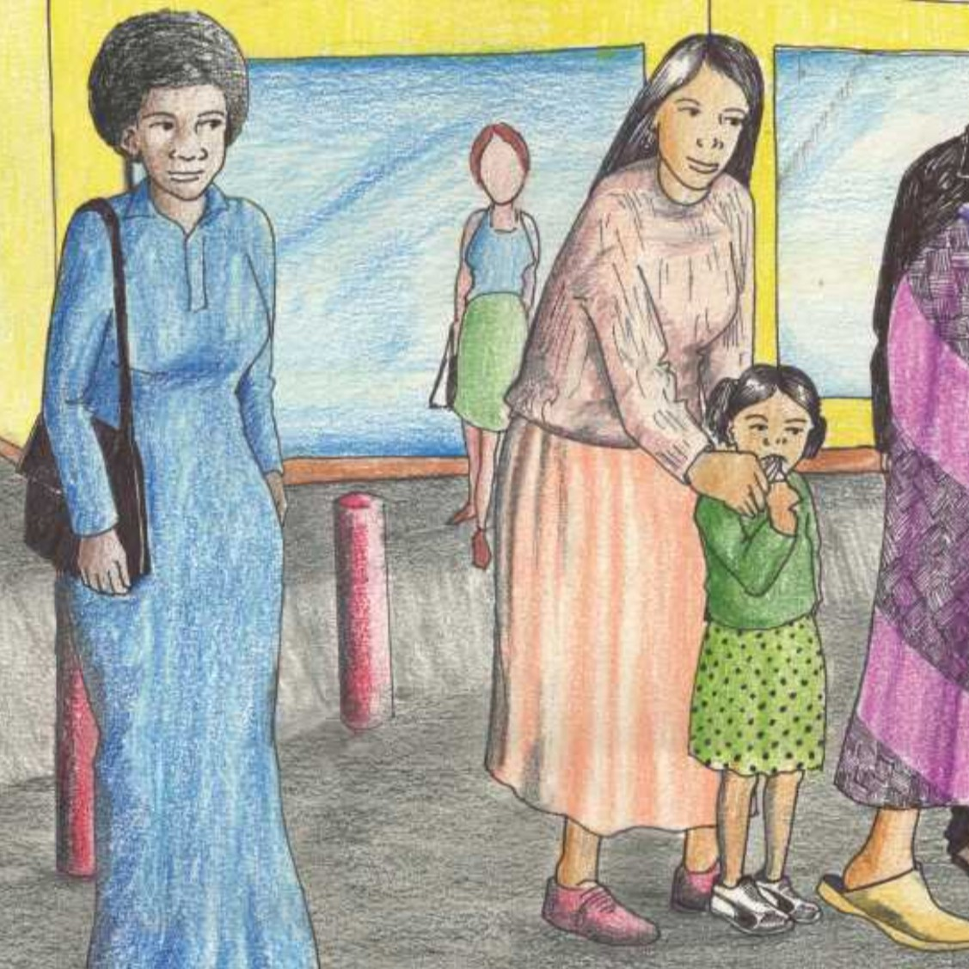

He makes his way through the people. Then he sees the man who is whistling. People are putting coins into a small tin in front of him.

But ... something is wrong ...

17

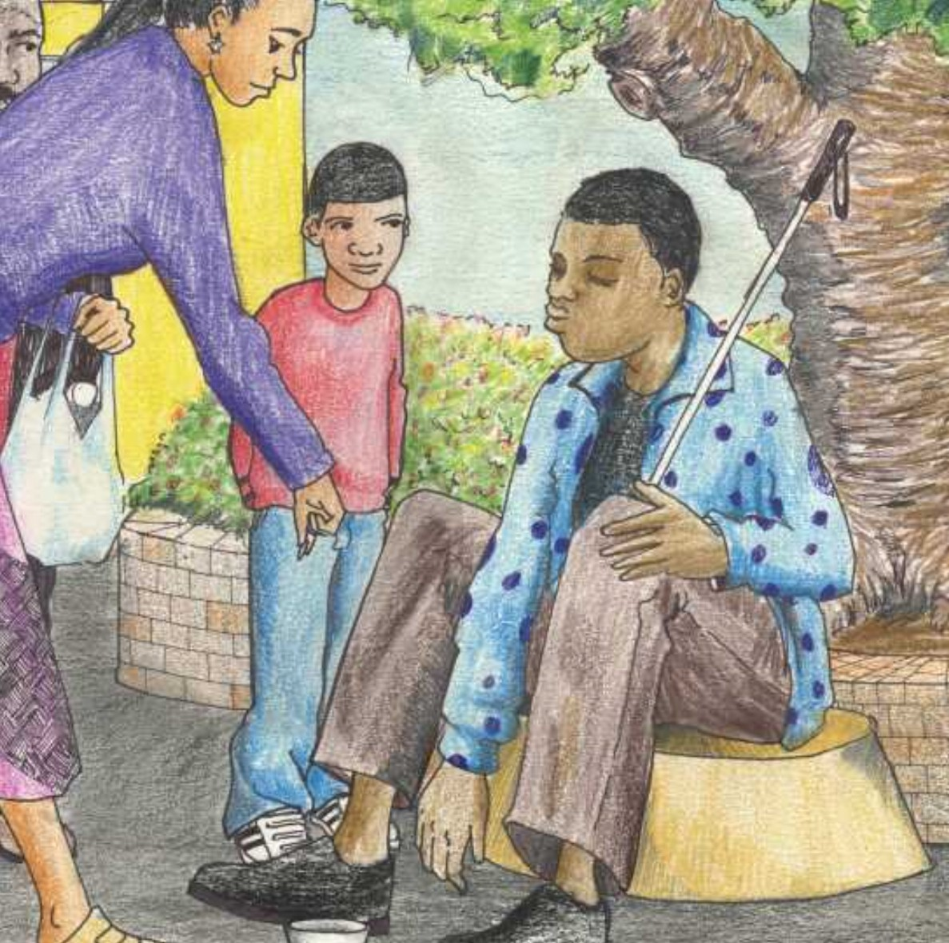

The whistling man is not looking at the people. He is not looking at the money.

He is not looking at anything. He’s searching for the coins in the tin and putting them into his pocket.

19

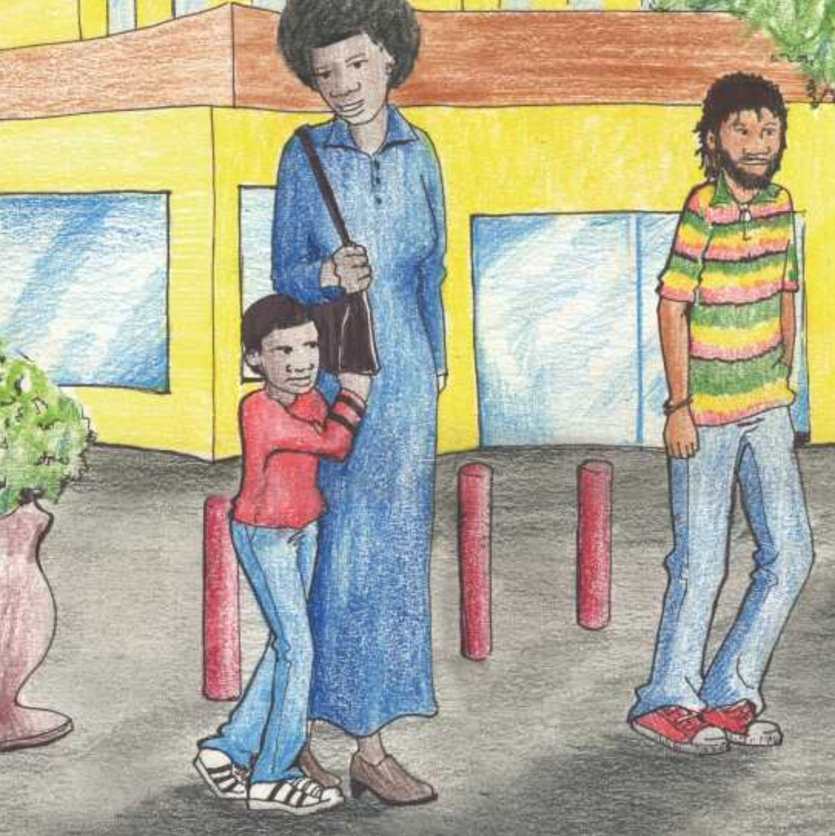

Rico stares at the whistling man and thinks, “Maybe he’s blind.” Rico has never seen a blind person before. He feels confused. He grabs his mother’s dress and asks softly, “Mommy, is that man blind?”

21

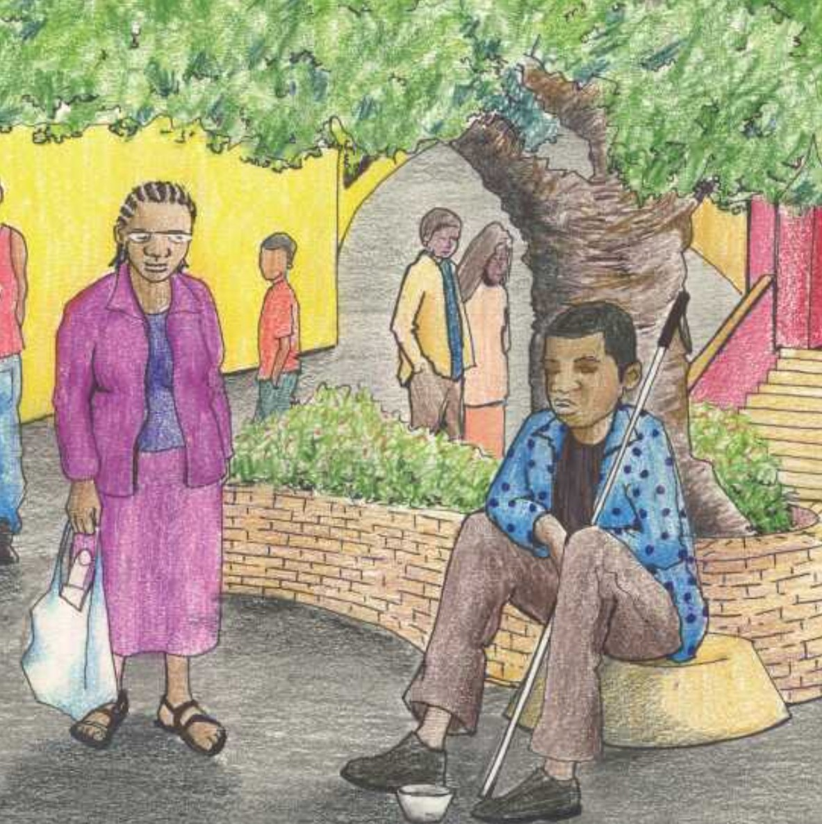

She takes his hand. “Yes,” she answers, “yes, he’s blind. Look, he has a white stick. Many blind people carry a white stick. He uses this stick to feel for holes and other obstacles.”

23

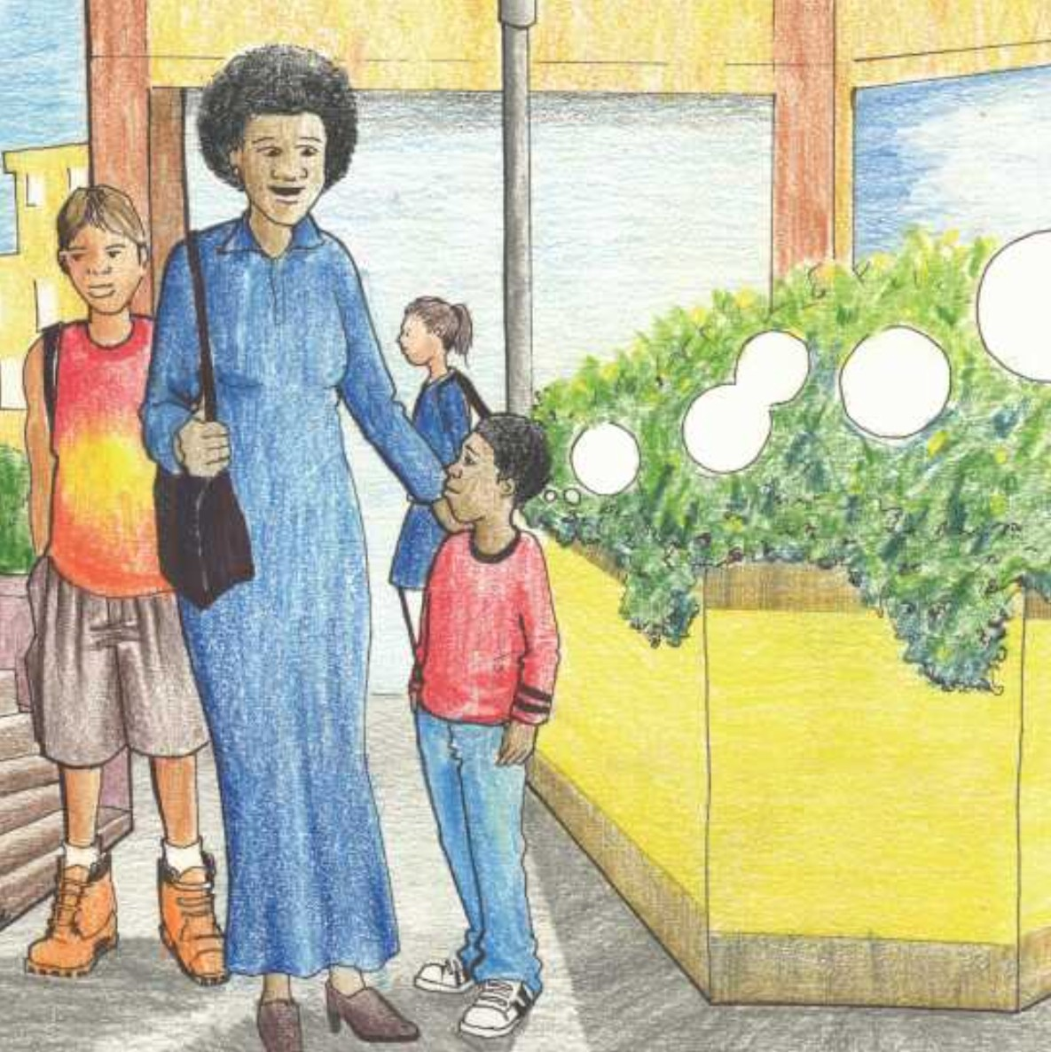

“But how did he come to town? How did he find his way through all the people?” Rico asks.

25

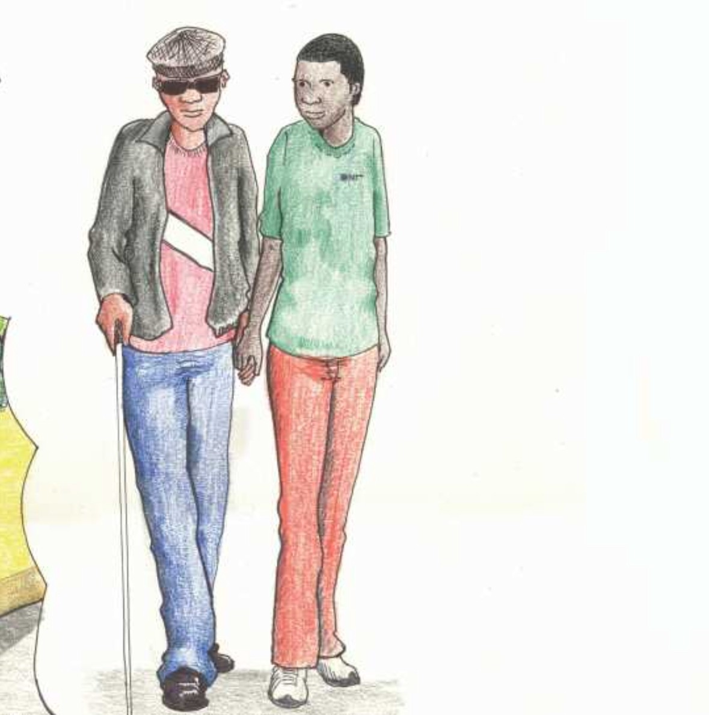

His mother tells him, “Maybe he has someone who helps him to find his way around. We call that person a guide.”

27

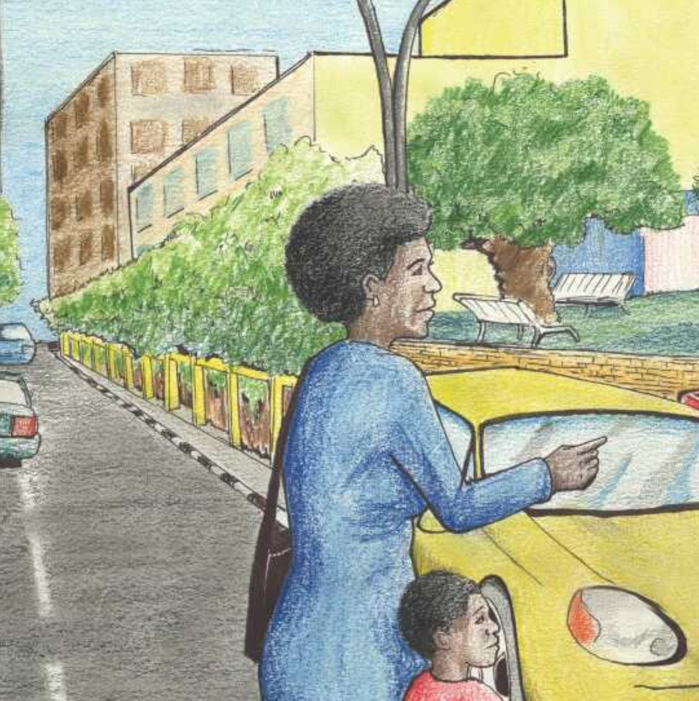

They walk to the Zoo Park*. The traffic lights change to green, the cars stop and the pedestrians cross the street.

* A park in Windhoek city centre

29

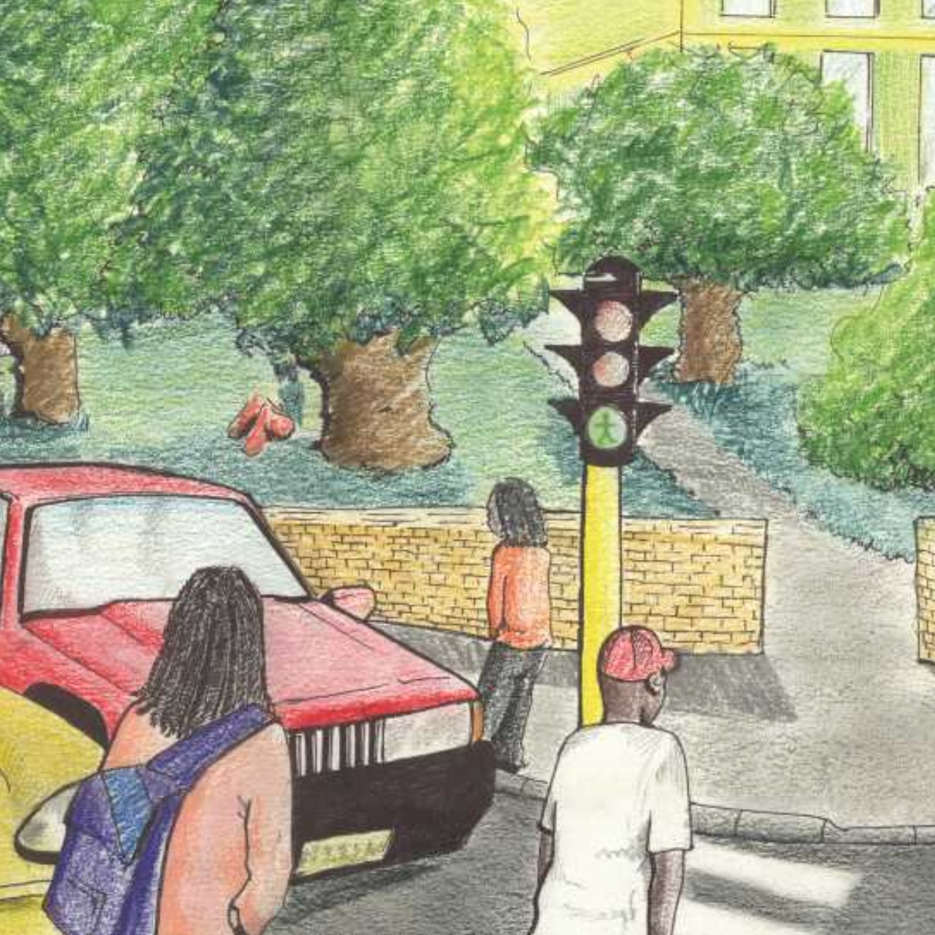

“Look at the green light. When it is green we can see it is safe to cross the road. In some countries there is also a beeping sound,” Rico’s mother says. “When blind people hear the beeping, they know it is safe to cross the road.”

31

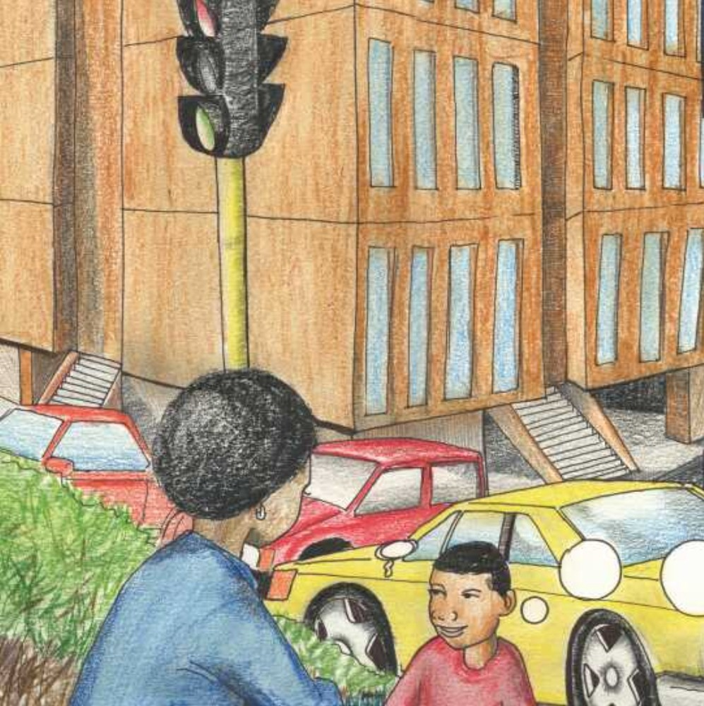

They sit on the green grass of the Zoo Park and watch the people walking by. “Some blind people have a guide dog,” his mother says. “These dogs are trained to guide their owner, but they are very expensive. There are very few guide dogs in Namibia.”

33

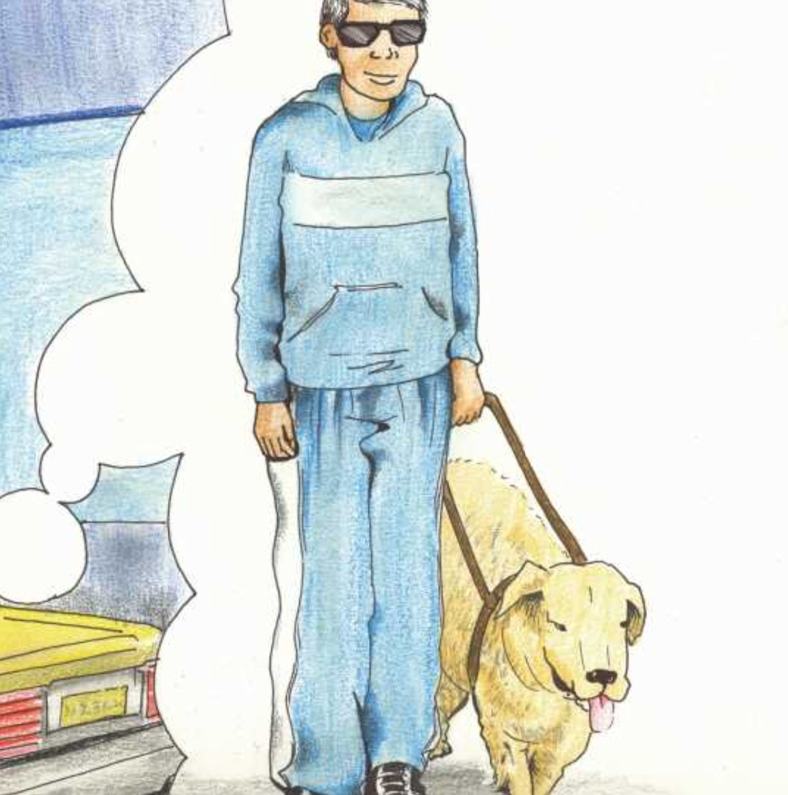

“The blind man can’t watch TV,” Rico says. “He can hear the TV and radio,” Rico’s mother tells him. “Blind people can often hear things much better than people who can see.”

35

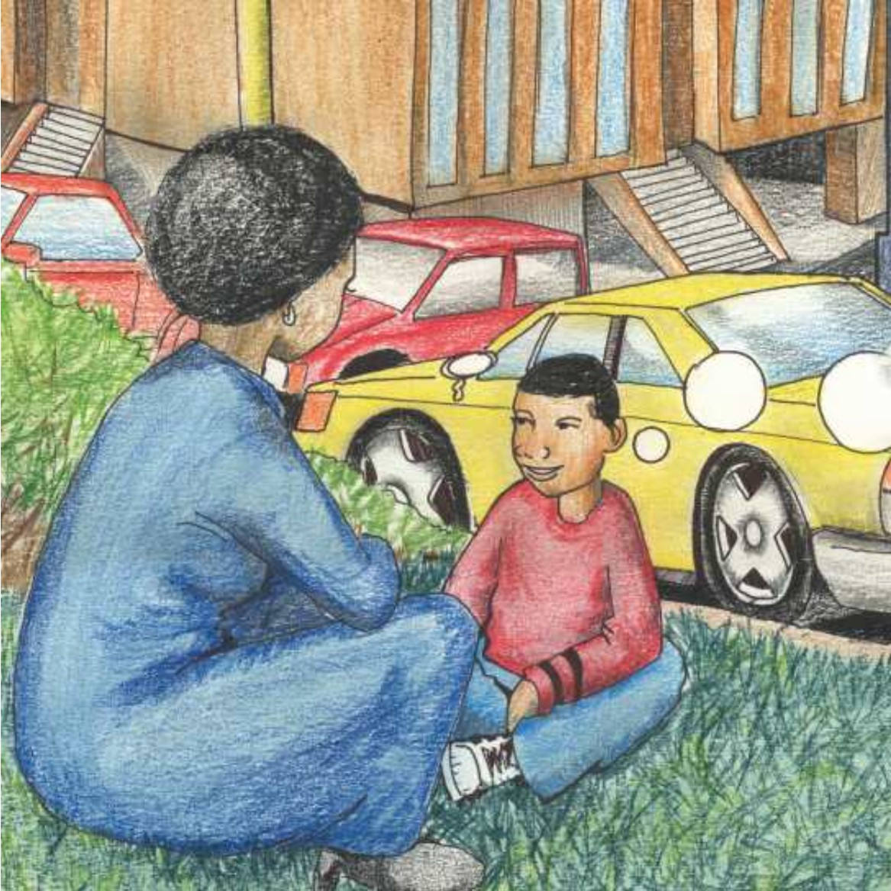

“But he can’t read books or newspapers,” says Rico. “There are books written in Braille. Instead of words printed with ink, there are raised dots which make letters.

It’s like a code.”

37

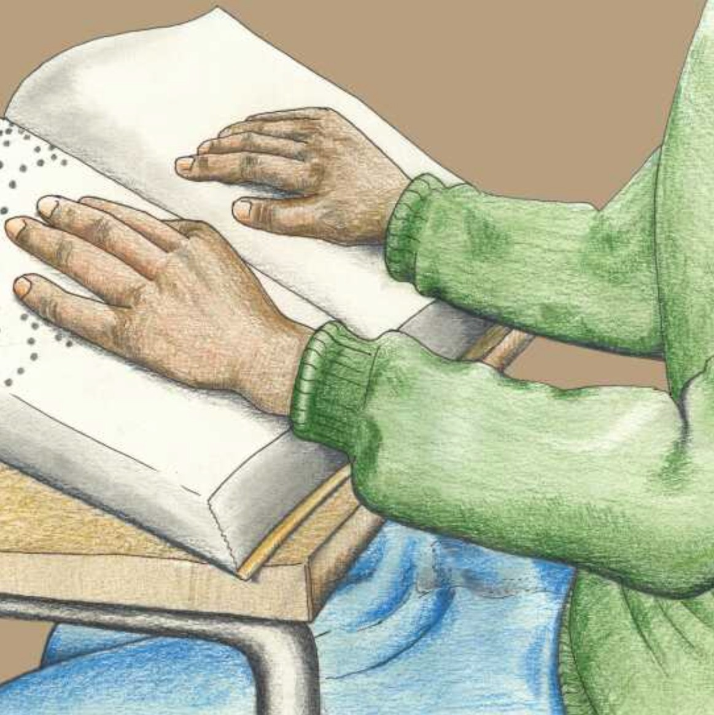

“How can he read if he can’t see?” “He reads with his hands. He feels the raised dots with his fingers, just like you see the letters with your eyes.”

39

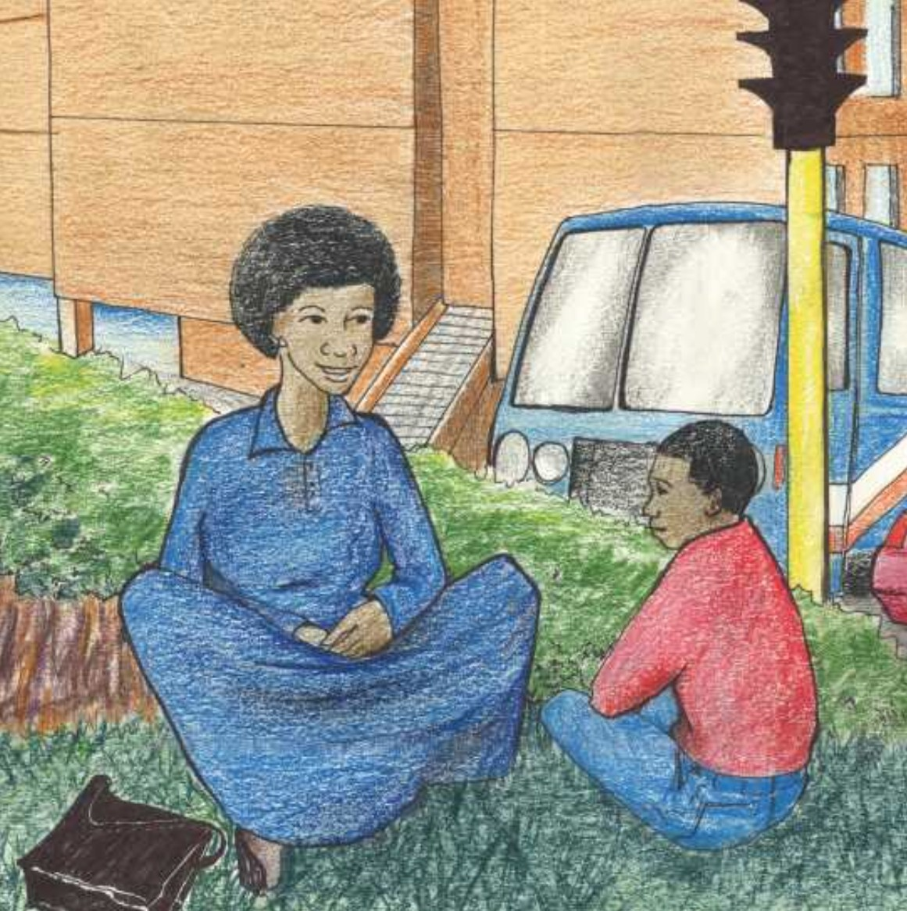

Rico is amazed to think that people who are blind can do everyday things; things like walking around in town, like whistling songs, like reading.

41

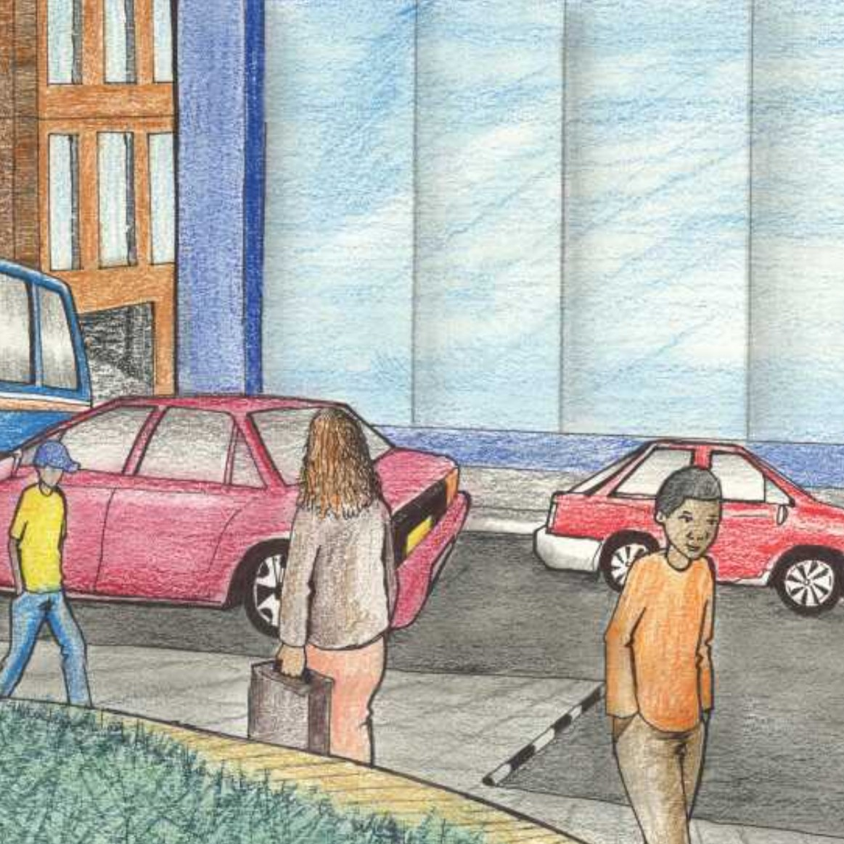

His mother tells him, “The only difference between you and a blind person is that you can see and a blind person can’t see.” “I can see, but I can’t whistle as beautifully as that blind man,” Rico smiles.

43

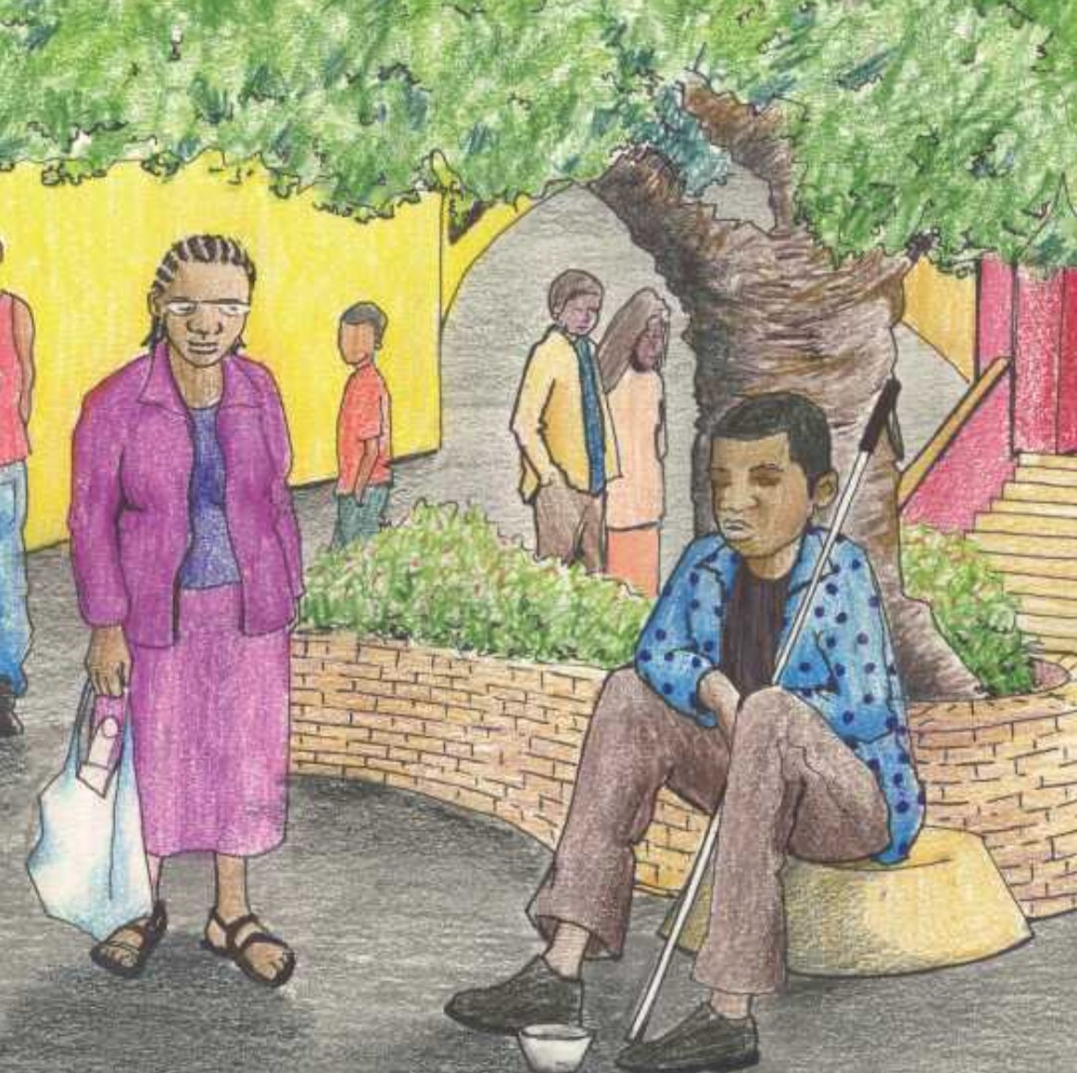

-THE END-

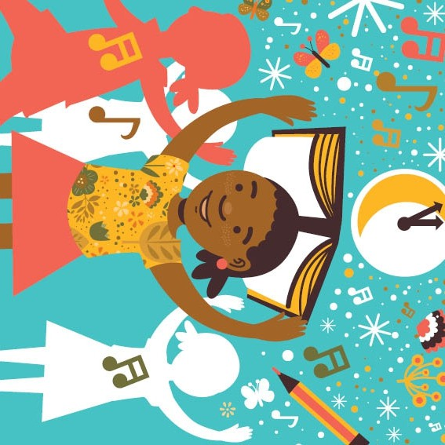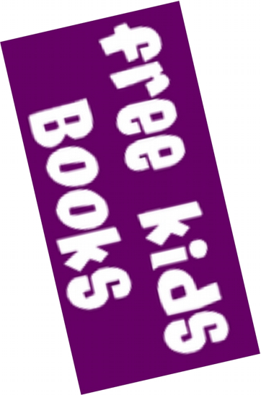

https://[www.freekidsbooks.org](http://www.freekidsbooks.org/)

Simply **great free books -**

Preschool, early grades, picture books, learning to read, early chapter books, middle grade, young adult, OER textbooks

Pratham, Book Dash, Mustardseed, Open Equal Free, and many more!

***Always Free – Always will be!***

This book is shared online by Free Kids Books at https://[www.freekidsbooks.org](http://www.freekidsbooks.org/) in terms of the creative commons license provided by the publisher or author.

**Want to find more books like this?**

YAY

!

**Legal Note:** This book is in CREATIVE COMMONS - Awesome!! That means you can share, reuse it, and in some cases republish it, but only in accordance with the terms of the applicable license (not all CCs are equal!), attribution must be provided, and any resulting work must be released in the same manner. Please reach out and contact us if you want more information: <https://www.freekidsbooks.org/about>

*This page is added for identification.*

*Image Attribution: Wesley van Eeden, Sinde and the Moon CC-BY-SA.*